Transition Vaulters Sponsorship Opportunities

The Transition Vaulters are a competitive Equestrian Vaulting team located in east Tennessee. This dynamic, exciting and fast growing equestrian sport originated in Europe more than 2000 years ago, was introduced in the Unites States in 1956 and is on its way to becoming an Olympic sport. Founded in 2008, the Transition Vaulters incorporated as a 501 (c) (3) non-profit organization in November of 2017.
The team, comprised of ten young women from Hawkins, Hamblen and Knox County, ages six to twenty five, is preparing for our 2018 season, competing at state, regional, national, and international venues. We also preform exhibitions for other charitable events and are planning our annual Open House.
The sport of equestrian vaulting encourages balance and harmony with the multidimensional movement of the horse, while promoting physical fitness and a strong sense of self confidence. A very special horse and intense training is required for the safety and success of our team. The Transition Vaulters operate from Renaissance Farm and are blessed with four talented and specially trained horses to practice and compete on.
Your tax deductible donation helps us transport our special horses and team to events, purchase equipment, and enables our Vaulters to achieve the long term goal of going for gold! With your help, we will achieve this goal. Sponsors will be listed on our website, on our team competition banner, and in the barn for visitors to see.
Our first competition of 2018 is in Covington, GA on April 14th and 15th. We welcome you to visit the farm and watch our team practice the amazing artistry of equestrian vaulting.
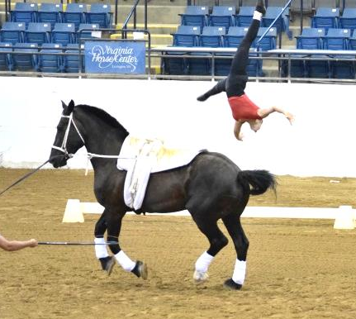
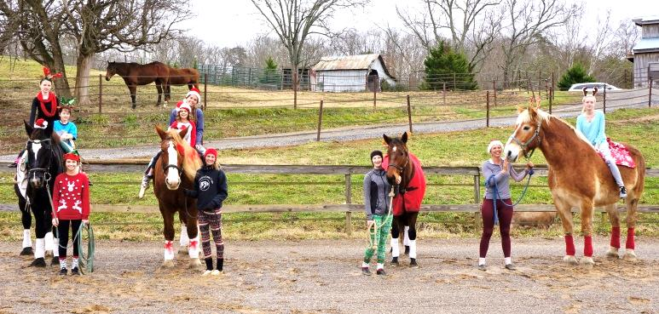
Meet the Transition Vaulters

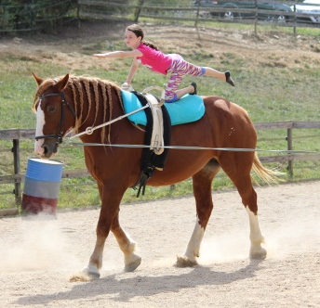
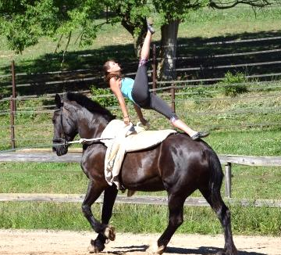

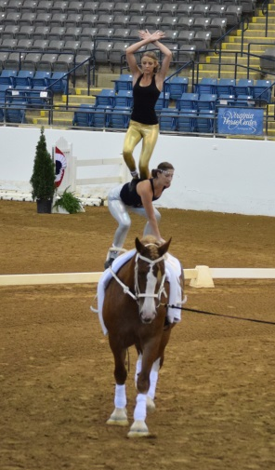
Renaissance Farm
196 Wolfe Branch Rd.
Bulls Gap, TN 37711
mblackstone@renaissancefarmtn.com
www.renaissancefarmtn.com
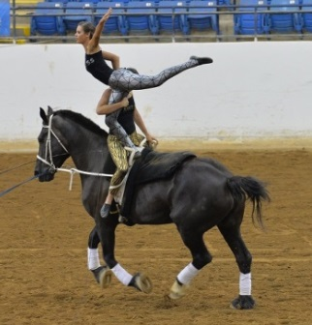
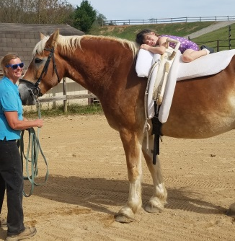
(423)-235-9070
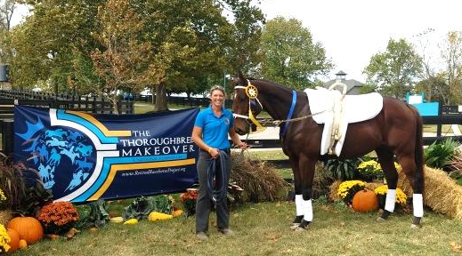

Transition Vaulters Equestrian Vaulting Team
Sponsorship Opportunities

Name/Company_____________________________________________________
Address____________________________________________________________
City______________________________ State_________ Zip Code__________
Email_____________________________ Phone #__________________________
Website____________________________________________________________
Donate Items
Donate products such as items for our open house raffle, new and used tack and accessories. Contact us for a list of appropriate items. I would like to donate the following items:
____________________________________________________________________________________________________________________________________________________________
Product Sponsors
Sponsor the team with the following products: ____________________________________________________________________________________________________________________________________________________________
Sponsors
Help us transport our special horses and team to events, purchase equipment, and enable our Vaulters to achieve the long term goal of going for gold!
$50 Bronze Sponsor
$100 Silver Sponsor
$250 Gold Sponsor
$500 Platinum Sponsor
Other Amount $___________
Event Sponsors
Event Sponsors help cover the cost of our Open House Dinner.

$250 Premier Event Sponsor
$500 Elite Event Sponsor
Other Amount $____________

Please makes checks payable to Transition Vaulters and
Mail to: Transition Vaulters 196 Wolfe Branch Rd., Bulls Gap, TN 37711

